Character Map Transformation

Hi Team,  
Please create new SSIS package for convert string columns in lower to Upper and Upper to lower.  
  
Please refer attached sheet(Ship Mode, Customer Name, Segment)

**Excel Source**

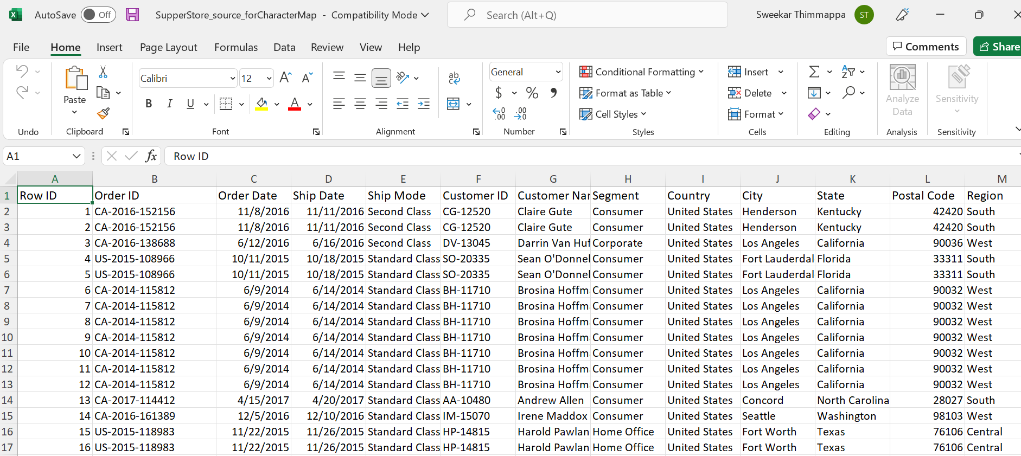

**Character Map**

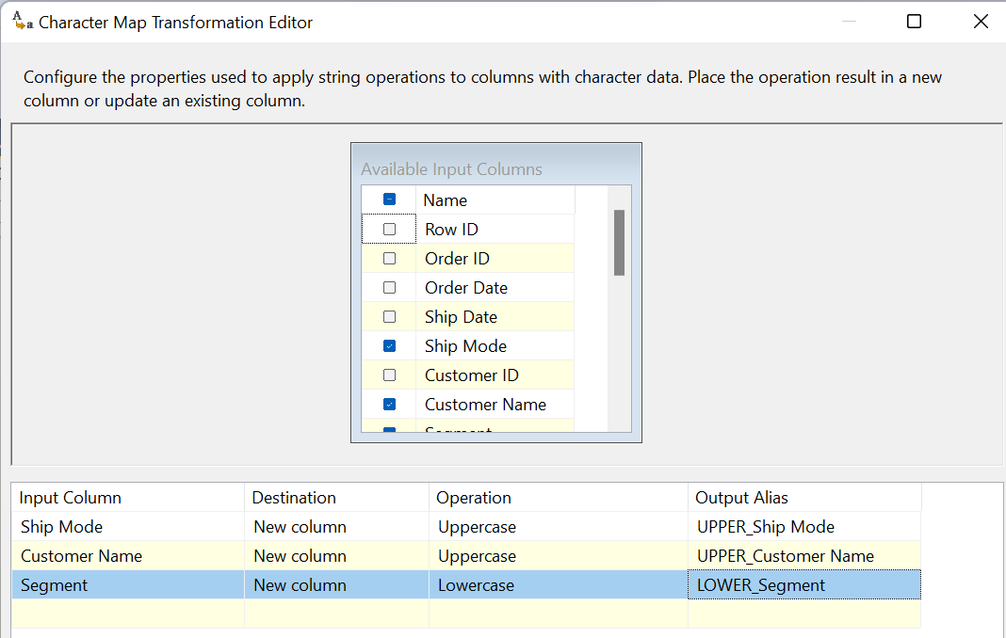

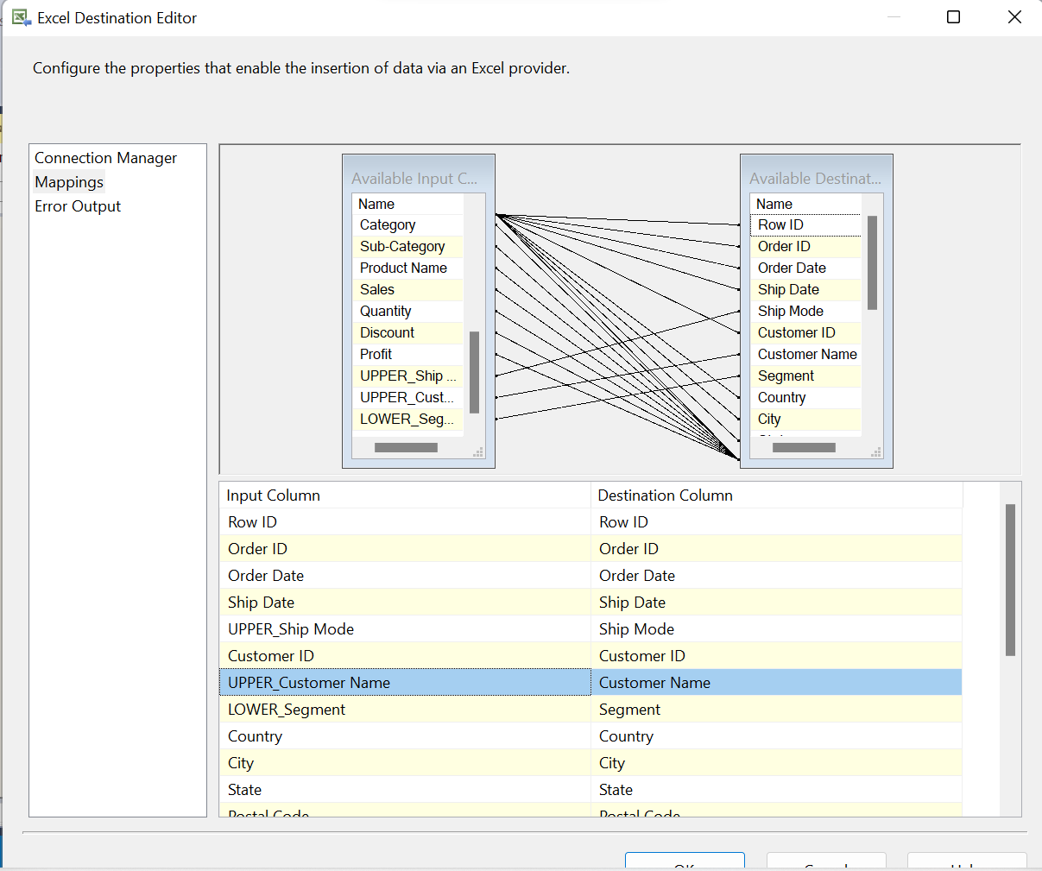

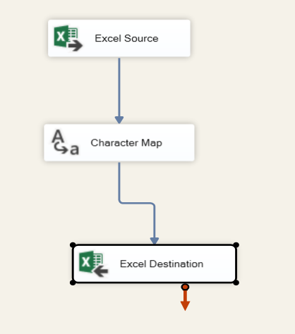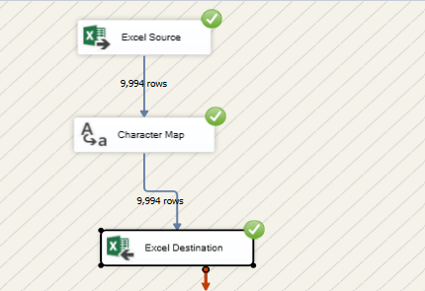

**Destination**

